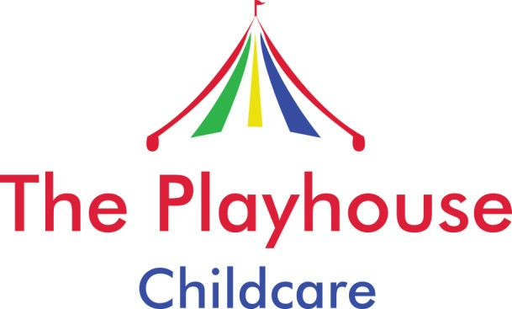

Accident/Incident Policy

The safety of your child is paramount and I will take every measure I can to protect your child from hurting themselves. However, sometimes accidents do happen and I have written the following procedure on how I will deal with such a situation:

- I will comfort the child and reassure them
- I will assess the extent of their injuries and if necessary call for medical support/ambulance
- I will carry out any first aid procedures that are necessary and that I have been trained to do
- Once the child is more settled I will contact you as soon as possible to inform you of the accident and if necessary to ask you to return to care for your child/ meet me at the hospital

After every accident, however minor I will:
- Complete an accident form
- Ask you to sign the accident form

If the incident requires any medical treatment then I will:
- Inform Ofsted (under Section 3, 3.49 Early Years Foundation Framework 2012)
- Inform my Insurance Company

It is important that you keep me informed regarding your child’s condition following an accident and if you have sought medical advice.

