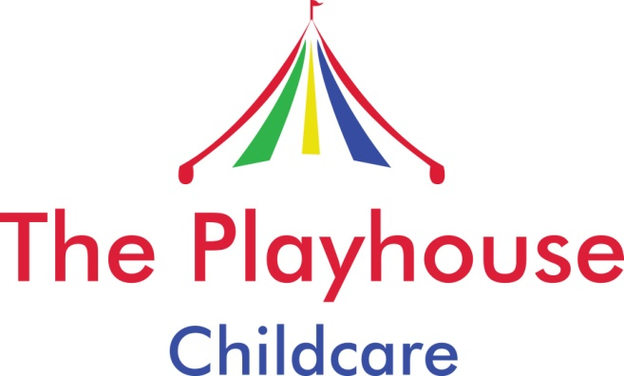

Childcare

Alcohol and Drugs Policy

As an Ofsted registered Childminder I work alone and will have sole responsibility for your child whilst they are in my care. It is vital that I am alert to any dangers and able to protect him/her. In order to do this effectively I must not be under the influence of alcohol or any form of drugs (including some prescription medication). If I am prescribed medication, other than routine antibiotics I must inform Ofsted who will make a decision as to whether I can continue to mind whilst taking them. I will not drink any alcohol during minded hours or immediately before.

If you have been drinking, perhaps a work leaving do, Christmas party or whilst entertaining clients I would prefer if you arranged for another responsible adult to collect your child, especially if you plan to drive home. Alternatively you may call me and I can delay the pick up time if possible.

Drugs and alcohol are now more readily available to younger children. If I have any concerns that your child may be drinking alcohol, taking drugs or smoking I will discuss the matter with you immediately.
I will then work with you to support your child, however I reserve the right to terminate our contract with immediate effect if I am concerned that your child’s behaviour due to drugs/alcohol may be putting the other minded children at risk.

